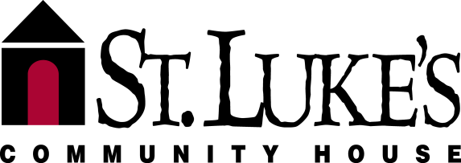
5601 New York Avenue • Nashville, TN 37209
Phone (615)350-7893 • Fax (615)350-7895
www.stlukescommunityhouse.org

The mission of St. Luke’s Community house is to help low-income working families, seniors, and individuals in West Nashville achieve their potential and prevent problems that threaten the stability of families and community.

VOLUNTEER APPLICATION

Name ___________________________________________ Date

Home Address City, State, Zip Code

Home Phone ___________________________ Mobile

Fax Number __________________ E-mail

Emergency Contact ___________________________ Phone

To ensure the safety of clients, staff and guests, St. Luke’s conducts background checks on all volunteers. Please provide the following information for an accurate background check.

Date of Birth ____________________ Age ____________ Gender : € Female € Male

Do you work outside of the home? € Full-time € Part-time € Retired

Place of Employment _____________________________________________________

Does your company have a time-off policy for volunteer work? € Yes € No

Does your company have a matching gifts program? € Yes € No

Are you currently a student? € Yes € No If so, where? ___________________________________

Education: € High School or Equivalent € College € Graduate School € Doctorate

Degree or trade obtained ________________________________________________

*Are you a member of a religious congregation? If so, which one?

Driver License Number ____________________ State of Driver License ________

AVAILABILITY
Do you prefer to volunteer on a € Regular basis € One-Time project € Both

How often are you available to volunteer with St. Luke’s?
€ One day per week € One day every two weeks € Once per month € Other:_________________

Which day(s) of the week do you prefer? ______________________ € Morning € Afternoon € Evening

AREAS OF INTEREST (select as many as desired)

Youth
€ Child Development Center (ages 6 weeks – 5 years)
€ After-school program: € Elementary School € Middle School € High School

Adults/Seniors
€ Food Bank € Mobile Meals € This ‘N That Thrift Shop € Senior Activities € Tax Preparation
Community Events
€ Spring/Summer Event € Halloween Event € Thanksgiving Event € Christmas Program
Administrative
€ Business skills/Organizing/Clerical Support € Events € Building/Property Maintenance

€ Other Interests ____________________________

SKILLS & EXPERIENCE

In addition to English, in what language(s) are you fluent?
€ Spanish € Vietnamese € Other __________________________________________

Would you be interested in assisting with translation and/or non-English speaking clients? € Yes € No

Other Skills & Experience

HOW DID YOU LEARN ABOUT VOLUNTEER OPPORTUNITIES AT ST. LUKE’S?

€ Current St. Luke’s Volunteer or Staff Member € St. Luke’s (i.e. newsletter, Facebook, etc.)
€ School/Work € Friend/Relative € Church € United Way
€ Media (Newspaper/Television/Radio) € Other non-profit agency € Court Ordered
€ Other ______________
What interests you about volunteering with St. Luke’s? _________________________

Share about your past volunteer experiences______________________________________________

